CASE STUDY 2
Group 5
Om Mihani (03803669)
Vyshnavi ARUNKUMAR (03803119)
Deepa RAMAKRISHNAN SUBATHRA (03799043)
2026

Task 1

Introduction
The aim of Task 1 is to study different interpolation methods and to understand how their mathematical properties influence the reconstructed curve. Using data set 1, linear interpolation, polynomial (Lagrange) interpolation, and cubic spline interpolation were applied and compared.

1.1: Piecewise Linear
The data_set_1 was first inspected and sorted with respect to the x-values. Linear interpolation was performed using Equation (1) from the lecture notes:
$$y=y_{i}+(y_{j}-y_{i})\frac{x-x_{i}}{x_{j}-x_{i}}$$
where $x_{i}$and $x_{i+1}$denote neighboring data points, and $y_{i}$and $y_{i+1}$are the corresponding measured values. For each interval [$x_{i}$,$x_{i+1}]$ the data points were connected by straight line segments.
The interpolated curve closely resembles the data, and this this method is simple and numerically stable. However, because of slope discontinuities, resultant function is not smooth, and the derivative is not defined at the data points.
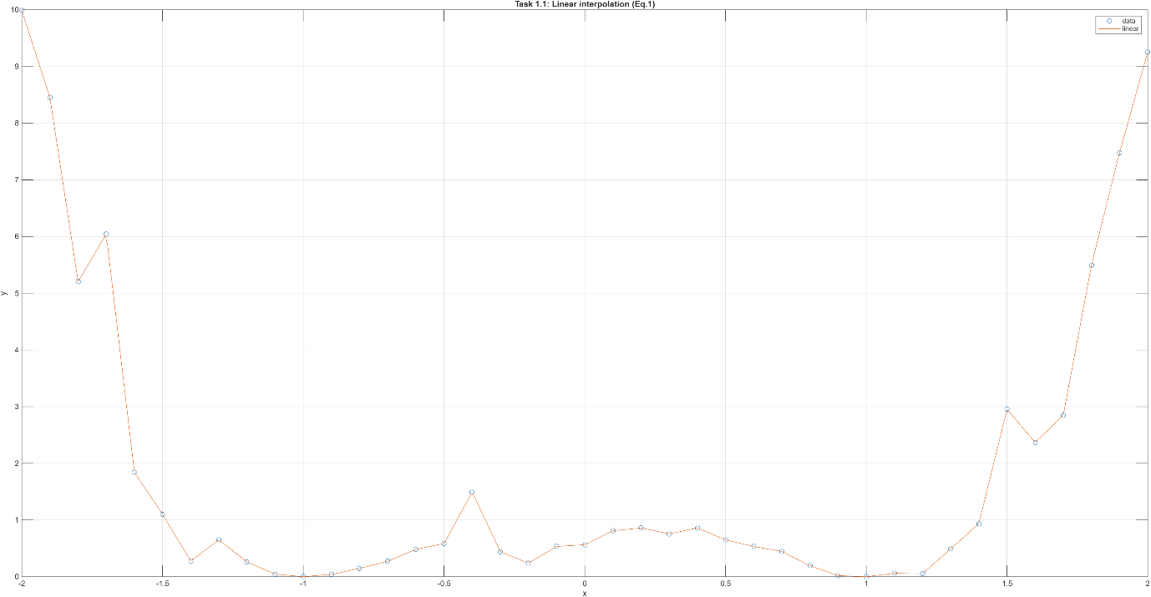
Figure 1.1: Linear Interpolation

1.2: Global Polynomial Interpolant
Step 1: Verification with lecture example

Lagrange interpolation formula given in Equation (2) was implemented for the lecture example points (0,1), (1,3) and (3,2):
$$π_{n}(x)=\sum_{i=0}^{n}{y_{i}}L_{i}(x),L_{i}(x)=\prod_{k≠i}{\frac{x-x_{k}}{x_{i}-x_{k}}}$$
where $x_{k}$are the interpolation nodes and $y_{k}$the corresponding data values. The function was tested against these data points from lecture which led to the identical results, proving that the base case works.
Step 2: Application to data set 1
Next, we apply it to the data range
$$-2≤x≤0$$
The resulting polynomial passes exactly through all selected data points, as expected from the theory.
Exactness: At the interpolation nodes, the algorithm is exact mathematically. However, notice that to match these values, the polynomial oscillates to orders of 1e7 at the borders, because it is being applied to larger number of points.
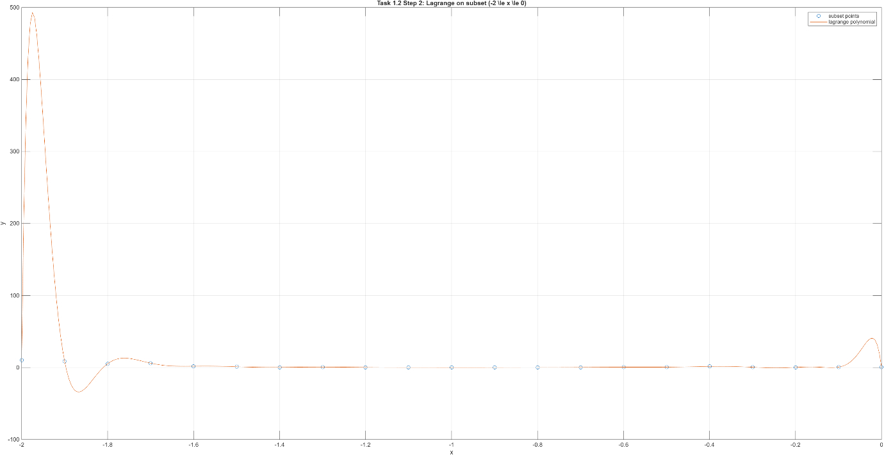
Figure 1.2: Lagrange Interpolation

1.3: Cubic Spline
For comparison, cubic spline interpolation was also applied. According to the lecture, cubic splines consist of piecewise third-order polynomials:
$$π_{i}(x)=a_{i}(x-x_{i})^{3}+b_{i}(x-x_{i})^{2}+c_{i}(x-x_{i})+d_{i},x_{i}≤x≤x_{i+1}$$
The spline interpolation passes through all data points while enforcing continuity of the first and second derivatives at the knots. The resulting curve is smooth and does not exhibit the strong oscillations observed in the global polynomial interpolation.

1.4: Comparison and Conclusion
The comparison of the three interpolation methods leads to the following conclusions:
- Linear interpolation is simple and stable but produces a non-smooth curve.
- Lagrange interpolation is exact at the data points but can introduce strong oscillations, especially for many points and near boundaries.
- Cubic spline interpolation provides a smooth and stable interpolation while still passing through all data points.
The comparison demonstrates that different interpolation methods can lead to very different curve shapes, even when applied to the same data set. Polynomial interpolation can introduce non-physical artifacts, whereas cubic splines offer a good compromise between exactness and smoothness. For proving this, observe the plot and its zoomed in version below.
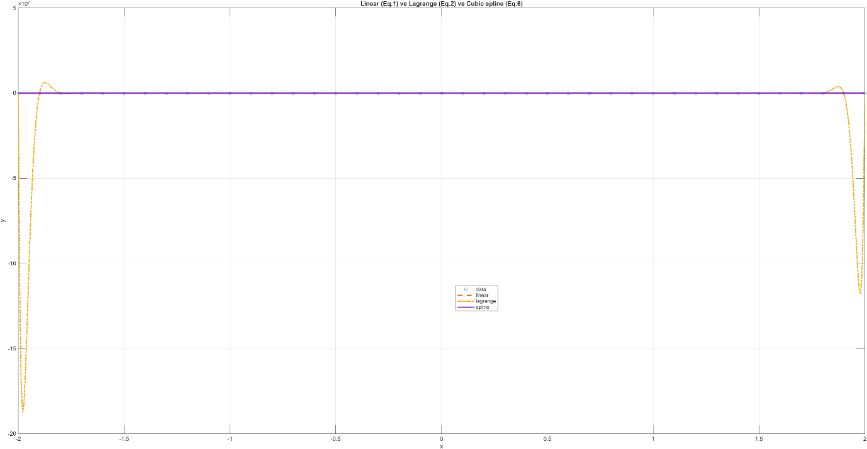
Figure 1.3: Cubic Interpolation with other two
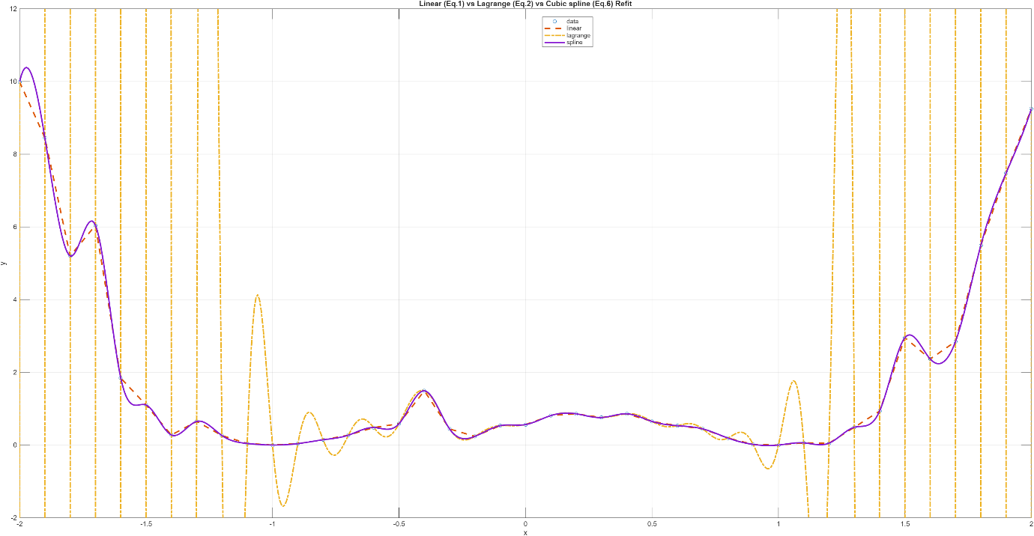
Figure 1.4: Zoomed in comparison

Task 2

Introduction
Experimental data describing the growth of a bacterial population X is given. A central kinetic parameter characterizing the microbial growth is the specific growth rate, which quantifies the relative biomass increase per unit time. This parameter is significant in biotechnology, as it provides insight for the state and growth dynamics of microorganisms.
The specific growth rate is defined as:
$$μ=\frac{ΔX}{Δt⋅X}≈\frac{\dot{X}}{X}$$
where $X$ denotes the biomass concentration and $t$the time.

2.1: Equation Formulation
During the exponential (logarithmic) growth phase, bacterial growth can be described by the rate of biomass increase is proportional to the current biomass. This leads to the differential equation:
$$\frac{dX}{dt}=μX$$
where $μ$is the specific growth rate and is assumed to be constant within the considered time interval.
Solving this equation yields the time-dependent biomass function:
$$X(t)=X_{0}e^{μt}$$
with $X_{0}$ representing the biomass at the initial time point $t=0$.
To estimate the “$μ$” from the given experimental data, the natural logarithm of the biomass is considered:
$$ln⁡X(t)=ln⁡X_{0}+μt$$
This transformation converts the exponential growth law into a linear relationship between $ln\left(X\right)$and time. As a result, the specific growth rate $μ$ can be determined as the slope of a linear regression of $\ln\left(X\right)$versus time. Assuming the exponential growth, the specific growth rate can be easily estimated from the given data by logarithmic transformation of the biomass and linear regression. This approach provides a simple and biologically meaningful method for growth rate estimation.

2.2: Average Growth Rate Calculation
Selection of the exponential Growth phase
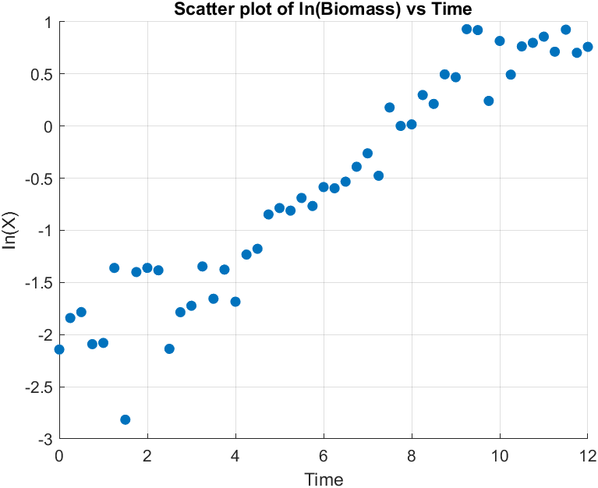
Figure 2.1: Scatter plot of the logarithm of biomass $ln⁡(X)$versus time for the experimental data.
From the given data, the values were plotted to identify the time interval in which exponential growth occurs. At early time, the biomass has fluctuations and doesn’t increase monotonically, indicating lag phase behaviour and some experimental noise. In contrast, between 3.25 h to 9.25 h, the biomass increases rapidly and consistently, indicating the exponential growth.
Therefore, the following time window was selected for the further analysis:
$$3.25≤t≤9.75$$
Within the selected time period, the biomass data were logarithmically transformed and fitted using linear regression. According to the derivation in Task 2.1, the slope of the fitted line corresponds to the average specific growth rate $μ$.
The regression was performed using MATLAB. The linear regression of $\ln\left(X\right)$versus time resulted in an average specific growth rate of:
$$\boxed{μ≈0.37{\text{h}}^{-1}}$$
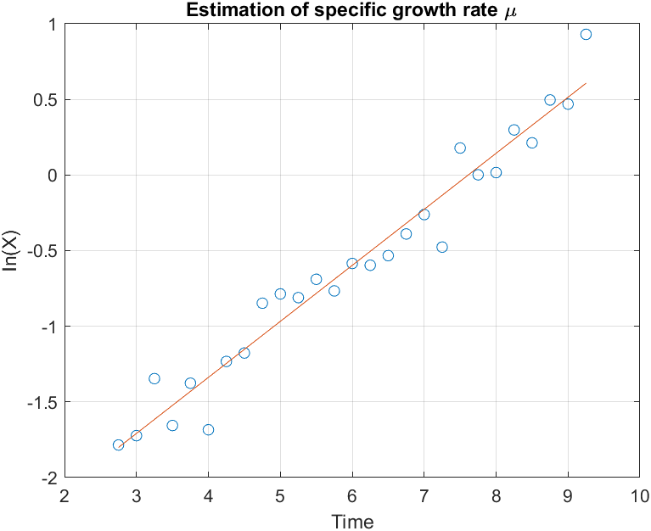
Figure 2.2: Estimation of the average specific growth rate $μ$
From the figure 2, the fitted regression line showed a nearly linear relationship confirming the validity of the exponential growth within the selected time interval. R2 was equal to 0.9442.
The estimated growth rate of approximately $0.37{\text{h}}^{-1}$indicates rapid bacterial growth, which is typical for microorganisms under favorable conditions. Minor deviations from linearity in the logarithmic plot can indicate the experimental noise.

Task 3

Introduction
When we deal with real life biological data, there is always inherent noise. This noise might have multiple different origins, including, instrument errors, measurement errors or simple unaccounted environmental factors like light or wind. However, we assume that the effect of these factors is small enough to still extract meaningful data from these experiments. One way to do so is regression which involves minimizing the error from the trend line globally. Smoothing is an advanced form of such a regression in which the effect is considered only locally instead of globally to get rid of extremely local noise while keeping the effect of sub-local variation preserved. While global regression minimizes total error across all points, often over-smoothing biologically relevant transients, local polynomial smoothing employs k-nearest neighbour weighted regression to suppress high-frequency noise while preserving sub-local dynamics. This case study attempts to study this smoothing technique. After achieving a smooth curve, we use the technique of numerical differentiation to find the growth rate.

3.1: Smoothing Analysis

3.1.1: Method
In this case study, two different parameters were studied, the span and the order of polynomial used. The code for this section contains two function files and a main file: “local_smoothing.m”, “local_smoothing_linear.m” and “main.m”. The function files take dependent variable, independent variable and the span as input while returning the output as a vector of the smoothed data. The weights used are tri-cubic and other options are selected as mentioned in the task file.
The spans selected are 5, 9, 13, 17, 21 and 25. This range is chosen considering the following factors:
- The span needs to be an odd number to consider a symmetric neighbourhood
- Span of 3 will not work for the quadratic function since it would be over specification
- Span more than 25 was clearly over smoothing since the span data had reached 50% limit.
We run the smoothing and do a subplot for each of the span values both for linear and quadratic fits. The plots are visible below as figures 1 and 2.

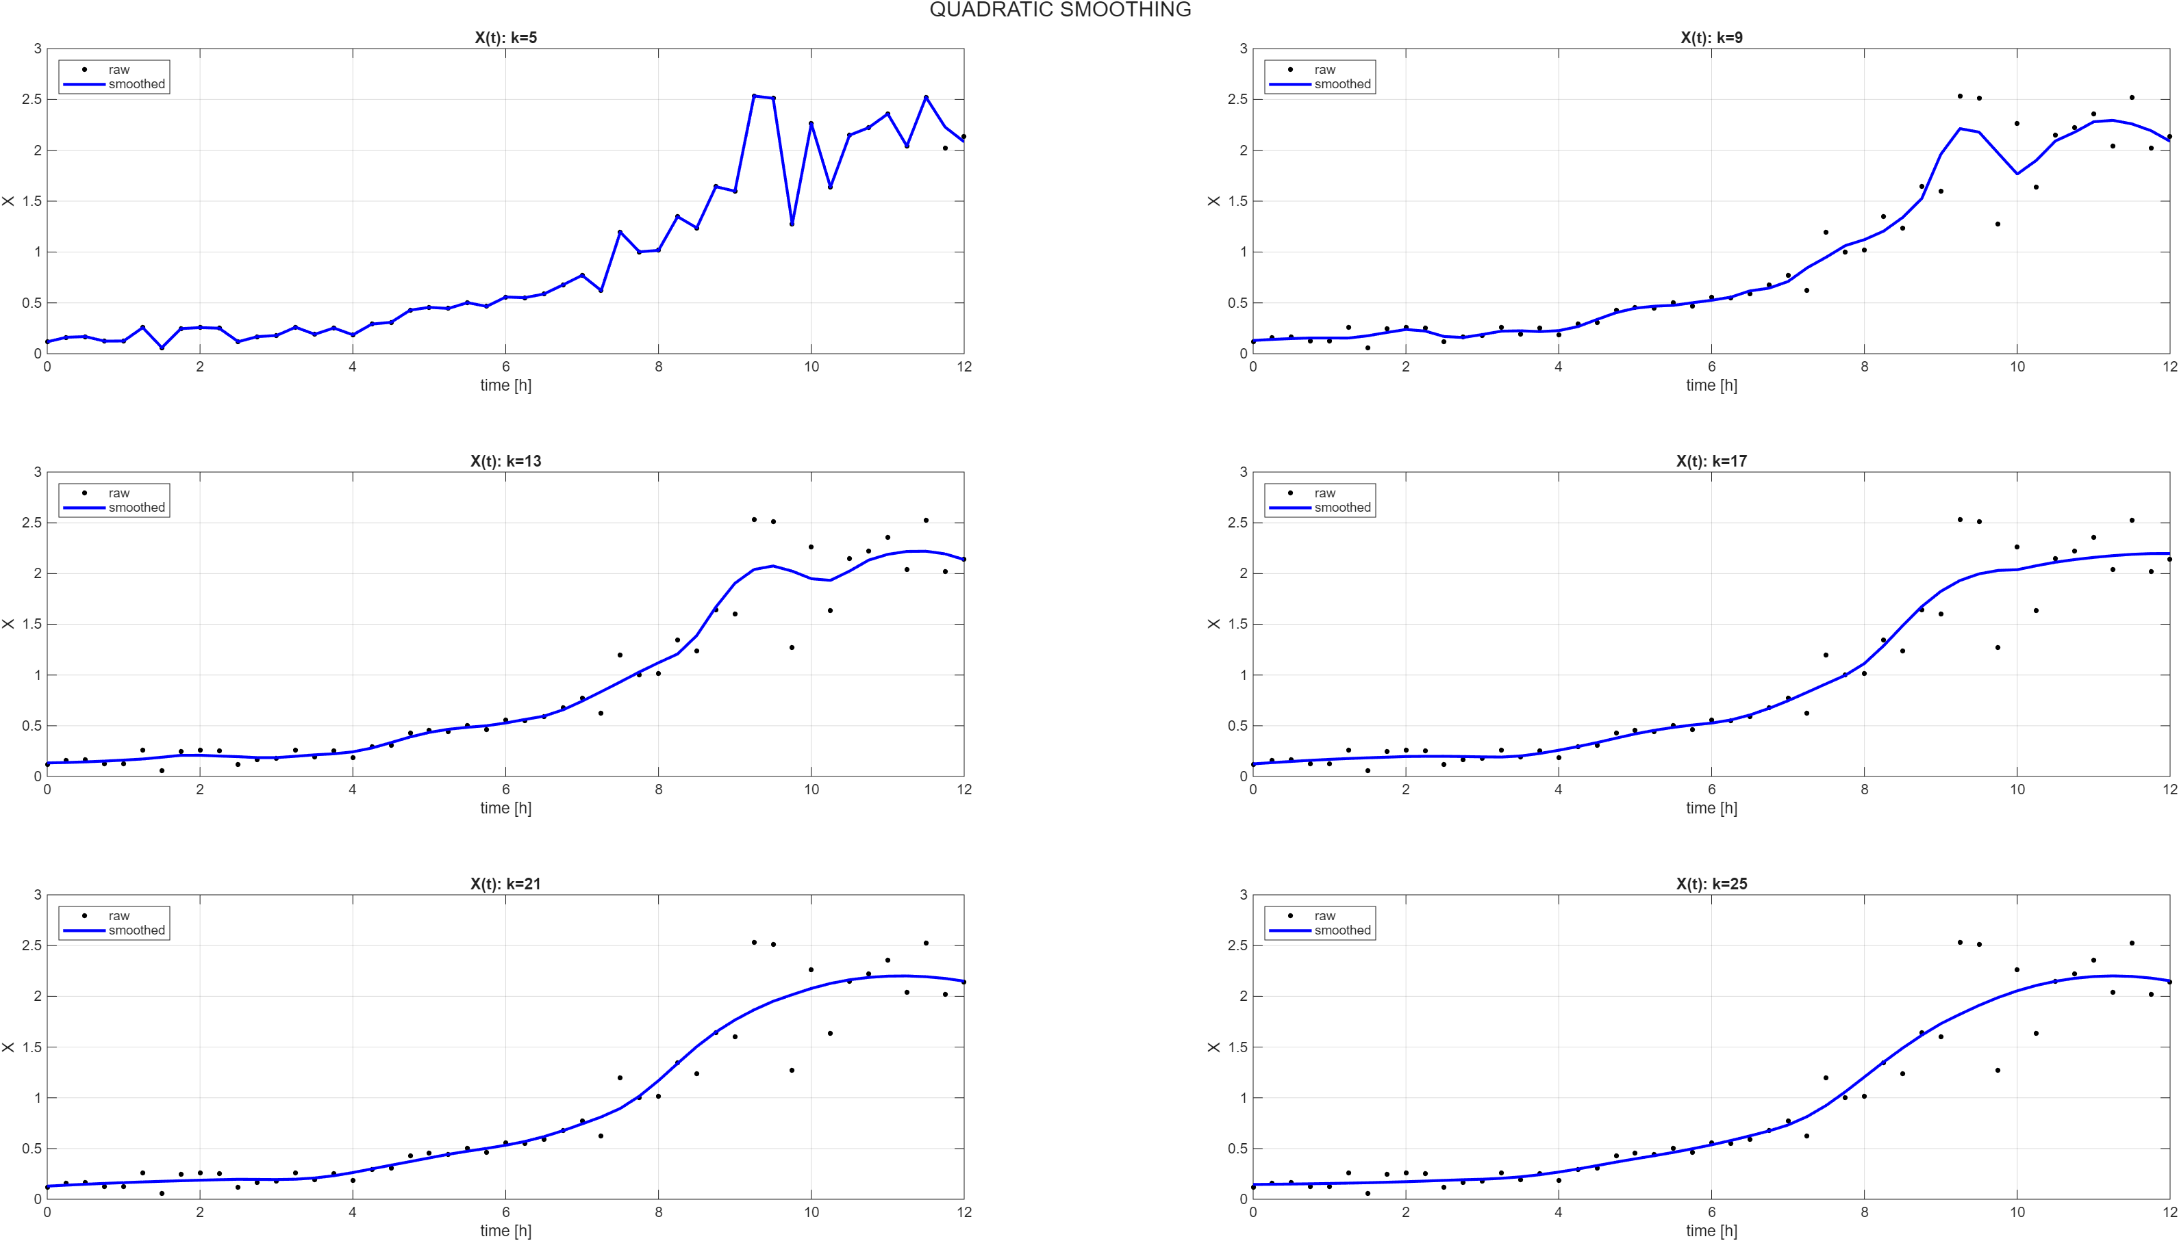

Figure 3.1: Quadratic Smoothing
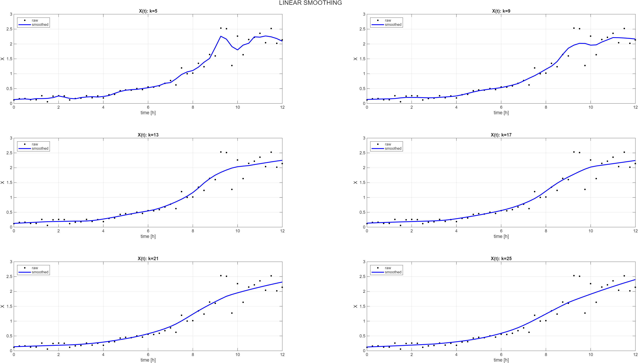

Figure 3.2: Linear Smoothing

3.1.2: Comparison
Let’s compare these 6*2 = 12 cases mathematically and visually. The metrics used are Root mean squared error and curvature. Root mean square error measures how far the smoothed values are from the real values. We want to avoid very high RMSE values since that would mean that our smoothed values are hypothetical and have no physical roots. We also consider mean of absolute curvature values. When the smoothed data is close to the ideal exponential growth and the noise is removed, the local curls are deleted, leading to a lower mean absolute curvature. Thus, our target should be to reduce the curvature without increasing the RMSE to a very high value.
We can fit an approximate curvature target by double differentiating the ideal growth curve:
$$\frac{d^{2}X}{dt^{2}}= μ^{2}X$$
We can either pick the $μ$ from the previous task or pick it regressively and select an average X from the logarithmic range. This gives the ideal curvature to be around 0.35*0.35*0.55 = 0.067 g/h². To allow a range, let’s allow 0.067 g/h² ± 20%. Note that the curvature of the raw data is 1.4761 g/h2.
K | Quadratic |  | Linear
K | RMSE | Curvature | RMSE | Curvature
5 | 0.0308 | 1.2476 | 0.1689 | 0.5638
9 | 0.1775 | 0.1928 | 0.5800 | 0.2428
13 | 0.1867 | 0.3221 | 0.2072 | 0.1080
17 | 0.2004 | 0.1524 | 0.2130 | 0.0782
21 | 0.2062 | 0.1272 | 0.2167 | 0.0597
25 | 0.2086 | 0.1076 | 0.2260 | 0.0443
Table 3.1: Comparison Metrics for Smoothing
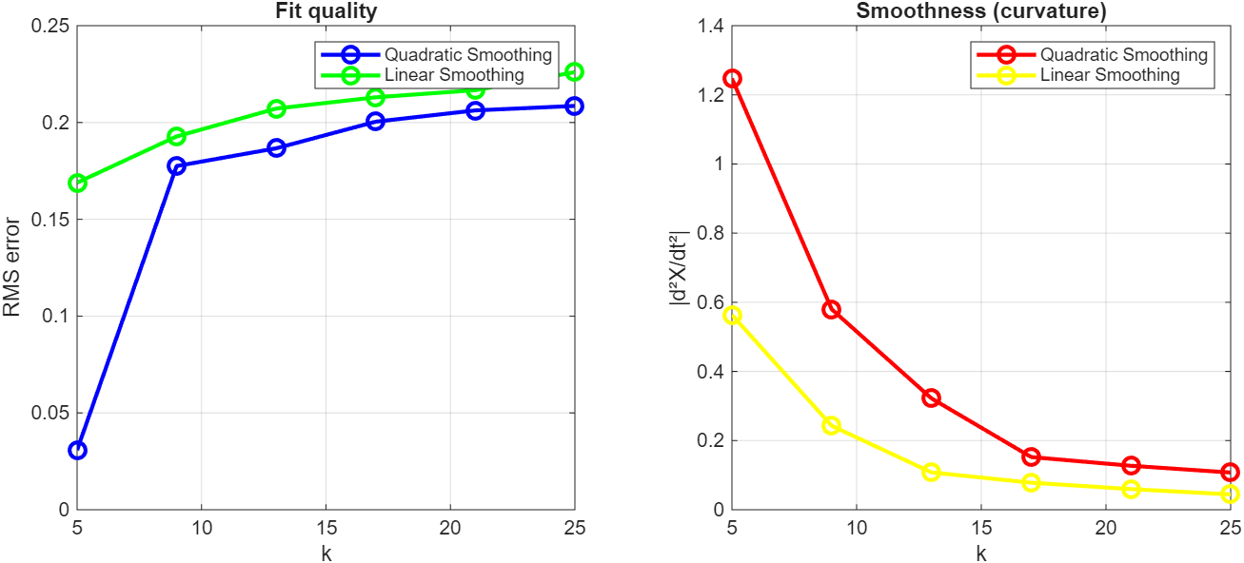
Figure 3.3: Comparison metrics

3.1.3: Observation and Analysis
Observe that for any given span, the quadratic smoothing has a lower RMSE than linear, i.e., it hugs the data closer. However, also observe that the curvature of each case is lower in linear than quadratic, meaning that the linear is closer to a trend-line. Next, observe the high span cases like k = 21 or k = 25 in quadratic for the timepoints after t = 9 hours. The data is clearly scattered at both the sides of the curve, showing high variability and noise while the quadratic function tries to fit a quadratic trend that doesn’t even exist or make sense. Moreover, observe that this time-period is better described by the linear smoothing. Finally, the linear curve hits the ideal curvature bracket at k = 17 with a curvature of 0.0782 and an RMSE of 0.213 while the quadratic is unable to achieve this even with a span of 25. Therefore, it can be recommended that linear is a better polynomial for smoothing when we want to observe the general trend like the average growth rate while a quadratic is better suited for cases where we want to see the perturbations in a standard curve since is able to capture the sub-local noise better.

3.2 Numerical Differentiation
In this section, we observe the effect of order on the numerical differentiation used for the raw and smoothed data. We use the predetermined optimal value of k = 17 for this analysis. The code has a function file which intakes the independent variable, dependent variable and the order. The code is made for the second and the third order. The boundary points are treated the same way for both the orders: forward difference at the starting point and backward difference at the end point. For the third order difference, at the second and penultimate time-points, 2nd order central difference is used. For comparison, we use the standard deviation metric.
Data | Order 2 | Order 3
Raw data | 0.502 | 0.649
Quadratic Smooth | 0.157 | 0.162
Linear Smooth | 0.090 | 0.091
Table 3.2: Comparison Metric for Differentiation
Observing these, one first intuition one might consider taking the second order difference due to a lower standard deviation. However, our requirement of the numerical differentiation is to compare the variability in calculation before and after smoothing. Therefore, it is important to select a difference tool that measures the noise more accurately. This makes the order 3 a better choice. Moreover, remember that order 3 is a more mathematically accurate method with a lower error order. Also, observe that for smoothed data, the difference in the two orders is lower. Finally, observe that the difference as well as the value of standard deviations is lower for linear smooth than quadratic smooth, proving that it is a better method of smoothing in this case.

3.3 Finding the Growth Rate
After establishing that order 3 is a better method for numerical differentiation, we use it to find the growth rate. The area of exponential growth is estimated using finding the area of almost constant growth rate. The said area is highlighted in this figure. 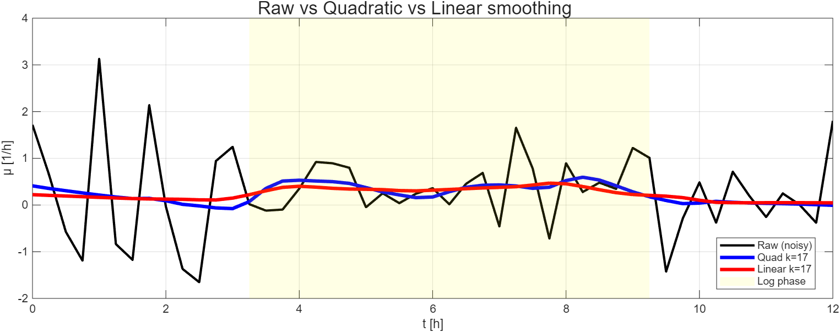
Figure 3.4: Growth Rate
Upon calculating the averages, we get:
Raw data: 0.4098 ± 0.5387
Quadratic Smoothing: 0.3732 ± 0.1386
Linear smoothing: 0.3424 ± 0.0671
The values are pretty close to each other, and you can observe that the standard deviation for the growth rate is raw data > Quadratic smoothing > linear Smoothing.

